- Poster Project: 50 points
Create a poster for colors—Be creative and create a poster for at least 9 basic colors in Chinese language for our classroom. The best two or three will be selected and posted on the walls of our classroom. This poster should include the following:
- Graphic demonstration of different colors (at least 9 different basic colors)Be creative how you present the colors. Include:
  - Graphic image of each color
  - Chinese Vocabulary and pinyin for each color : For example:
  - Example 1: (English is unnecessary)
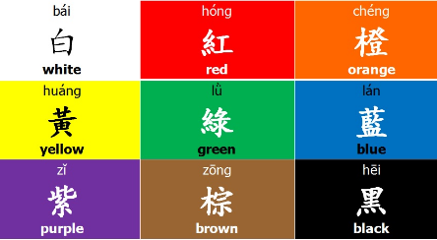

Ex 2 (but it would be better to add the Pinyin on the bottom for each colors)
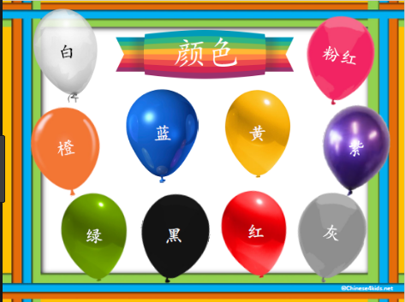

Due date: This is due on Tuesday after coming back from the Spring break.

- Poster for a Color Poem 50%:

Use this color poem template to create a Color poem in Chinese:

颜色诗Color Poem Template
Title (题目): _____________________________
(selected color) is .... (选的颜色)是。。。
(selected color) is .... (选一个颜色)是。。。
(selected color) is .... (选一个颜色)是。。。
(selected color) is .... (选一个颜色)是。。。
(selected color) tastes like .... (选一个颜色)吃起来像。。。
(selected color) smells like .... (选一个颜色)闻起来像。。。
(selected color) sounds like .... (选一个颜色)听起来像。。。
(selected color) feels like .... (选一个颜色)感觉像。。。
(selected color) looks like .... (选一个颜色)看起来像。。。
(selected color) makes me feel.... (选一个颜色)让我觉得。。。
(selected color) is .... (选一个颜色)是。。。

Vocabualry for the words used in this template:
选xuǎn: select/闻 wén: smell/ 感觉 gǎnjué: feel/像xiàng: like/ 让ràng: let, make

Due: Thursday, April 4th
Get ready to read out loud in front of the class.

The EnglishTemplet for this color poem is drawn from http://www.readwritethink.org/files/resources/lesson_images/lesson375/PoemTemplates.pdf

